**ASSIGNMENT JAVA WEB APPLICATION – PRJ301**

**(SELLING ONLINE (CLOTHES) – Borcelle)**

**I. MEMBER**

|  |  |
| --- | --- |
| **Full Name** | **Role** |
| 1. Bui Thuy Linh Student Code: **HE172129** | Java Back-End (Java, Servlet) |
| 2. Dang Quang Anh  Student Code: **HE171836** | Front-end  (HTML, CSS, JSP) |

**Instructor: Phan Dang Cau (CauPD)**

**II. Description**

We decided to choose the theme of an online clothing selling website for our business project for specific reasons and a strict business strategy. First and foremost, the online fashion market is becoming an important part of the retail industry, creating a huge business opportunity. Furthermore, reaching customers online helps us expand our business reach, not limited by geography. This increases the opportunity to reach a wide customer base without having to have physical stores in multiple locations.

Second, the fashion market is constantly changing, which creates diversity and stimulates creativity in product selection. We can flexibly adjust our product portfolio to meet market needs and customer preferences. This innovation is key to maintaining customer excitement and expectations, helping us continuously improve and develop our products.

Third, building a website to sell clothes online also gives us the ability to optimize customer experience. We can leverage technology to provide convenient features like quick search, secure payments, and door-to-door delivery, all with the goal of creating the best online shopping experience for customers. ours. This convenience and positive experience will certainly increase customer loyalty and create trust on their part.

Finally, choosing a website theme to sell clothes online also provides opportunities for growth and business expansion in the future. With the continuous increase in online shoppers, we have been able to build a strong and reputable brand in the market, leading us to new business opportunities, including partnerships with famous designers, increase advertising and marketing, as well as expand the global partner market.

We believe that incorporating these elements in our business strategy will help us succeed in the online fashion market today and in the future.

**III, Database**

|  |  |  |
| --- | --- | --- |
| **STT** | **Tables** | **Properties** |
| 1 | Category | CategoryID [int], CategoryName [varchar(255)]. |
| 2 | Product | ProductID [int], ProductName [varchar(255)], Quantity [int], Price[int], image [varchar(255)], cid [int – foreign CategoryID (Category)]. |
| 3 | Customer | CustomerName [varchar(255)], Username [varchar(255)], Password [varchar(255)] |
| 4 | Cart | CartID [int], ProductName [varchar(255)], Quantity [int], UnitPrice [int], TotalPrice [int] |
| 5 | Buying | AdminUser[String], ProductName[String], Quantity[int], Price[int], image[String], cid[int] |
| 6 | Order | OrderID [int], CustomerName [varchar(255)], CustomerAddress [varchar(255)], PhoneNumber [varchar(255)], ProductName [varchar(255)], Quantity [int], UnitPrice [int], TotalPrice [int] |

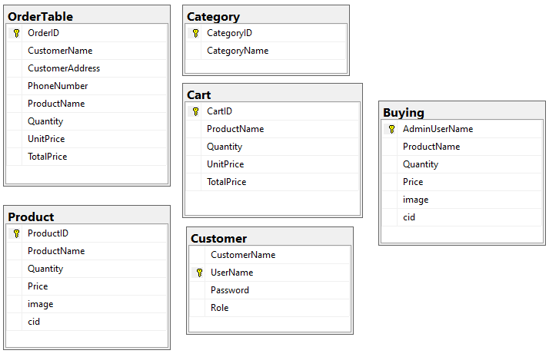

**IV, System Design**

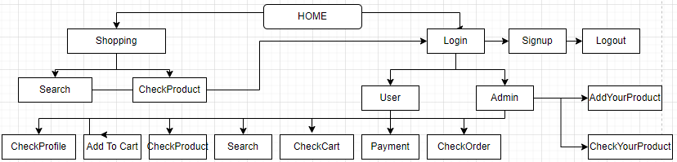

User start with Home Page

* If users continue shopping, they will access Product and Search product by CategoryID (Woman, Man, Children).

+ If they want to Add to Cart/ Payment/ Check your Cart/ Check Order, they must login to system.

* If users choose login, they must have an account. If they don’t have an account, they must sign up. After signing up successfully, they login again and then they can shopping with user interface.
* If you’re user

+ Can access product, search product

+ Can Add to Cart or Payment (after choose one of all product in their screen)

+ Can check profile (name, avatar)

+ Can check Cart (All product you added to Cart before)

+ Can delete a product in cart

+ Can check Payment (All product you payment before)

+ Can log out.

* If you’re admin

+ You can do everything as user

+ Addition: Add admin’s product and check them.

**IV, Explain by photos**

First Page:



Home Page:

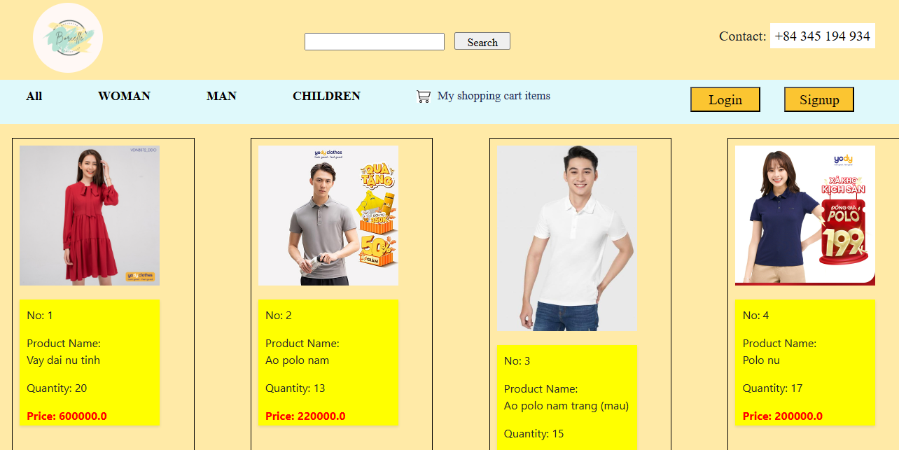

Search Page:

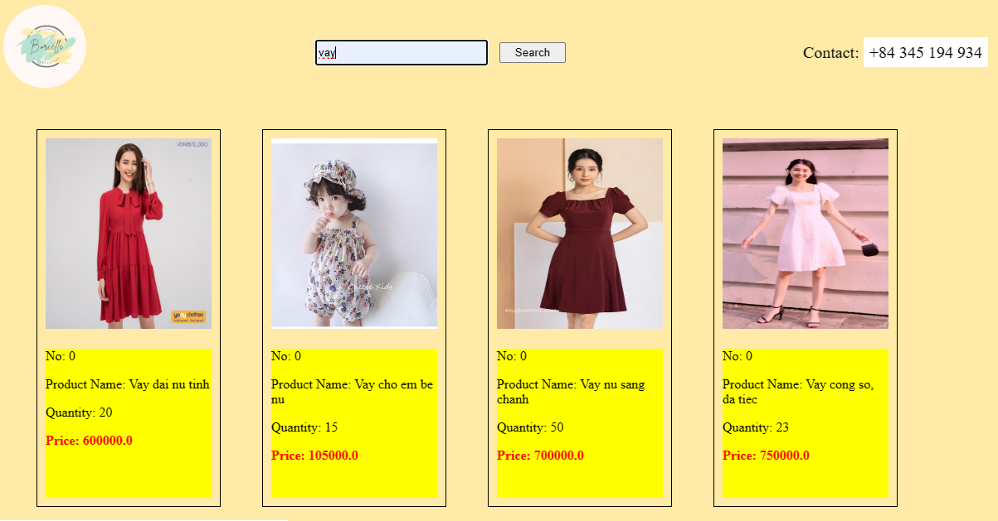

Product By CategoryID Page:

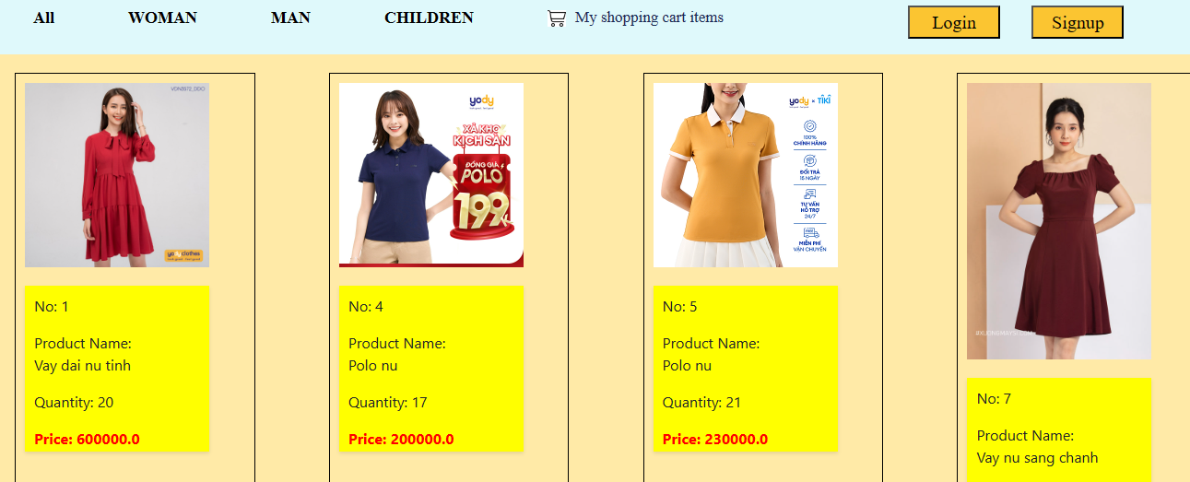

Login Page:

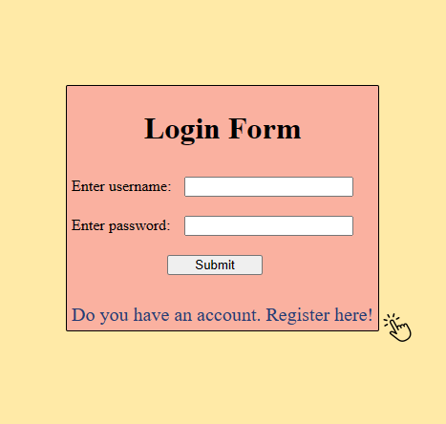

Signup Page:

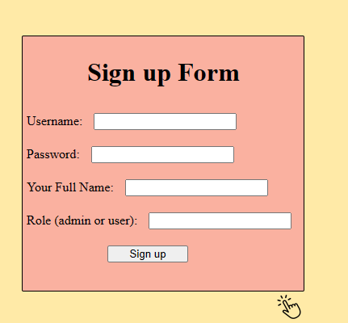

Account Page:

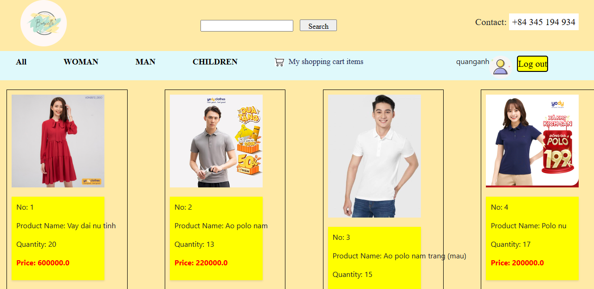

Profile Page:

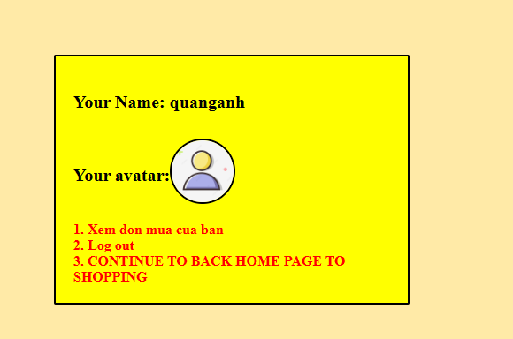

Product Page:

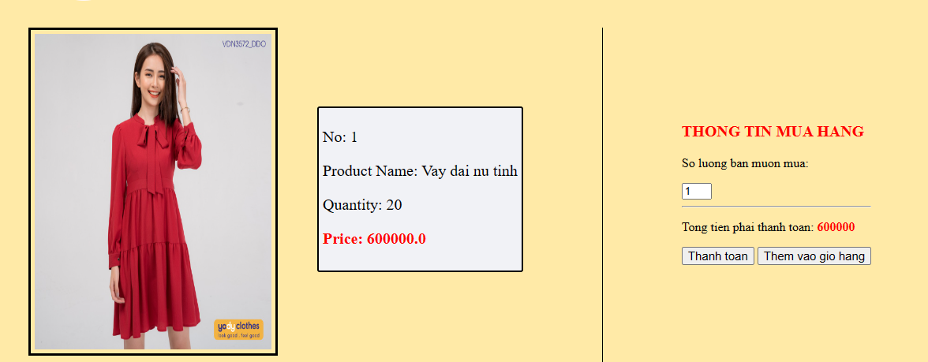

Payment Page:

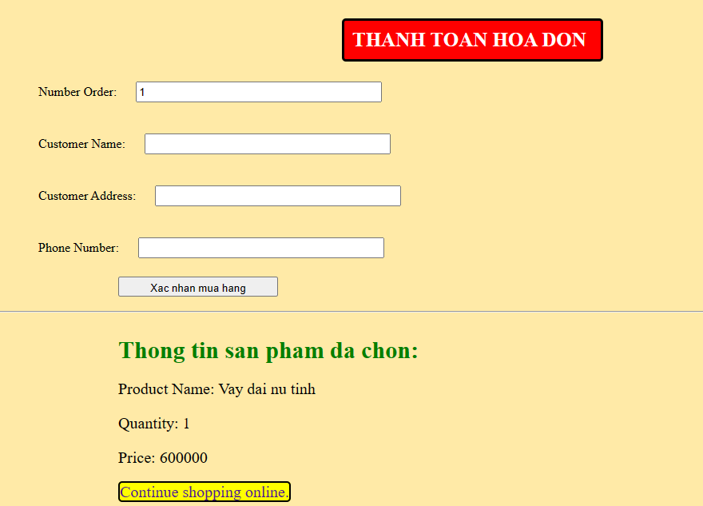

Order Page:

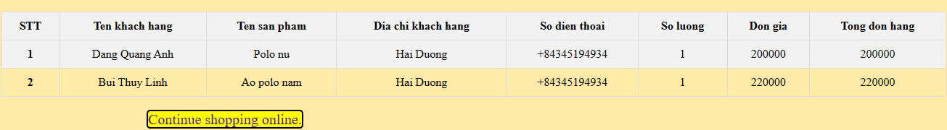

Add to Cart Page:

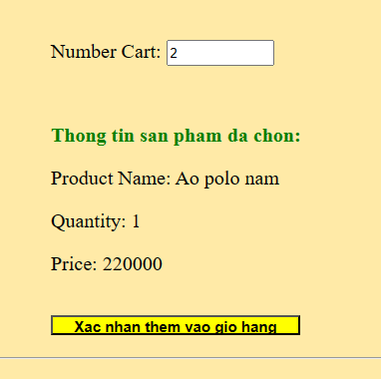

Cart Page:

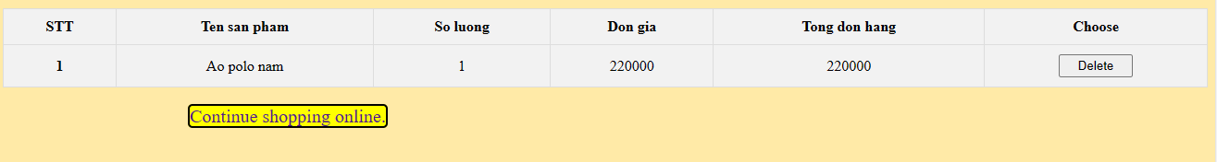

Admin Page:

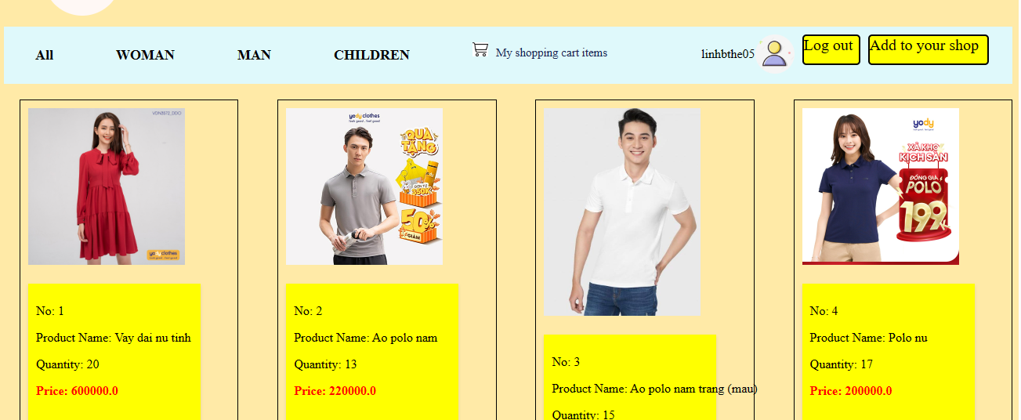

Add admin’s Product:

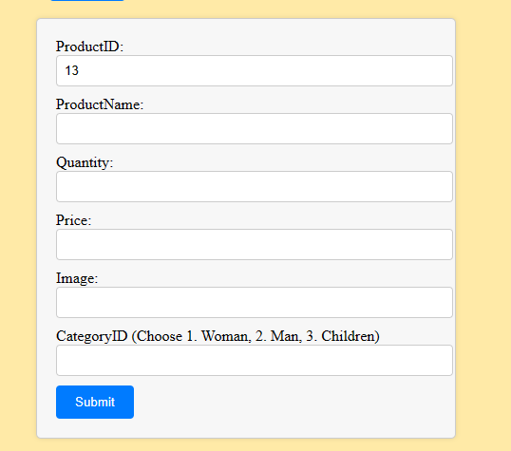

Check admin’s Product:

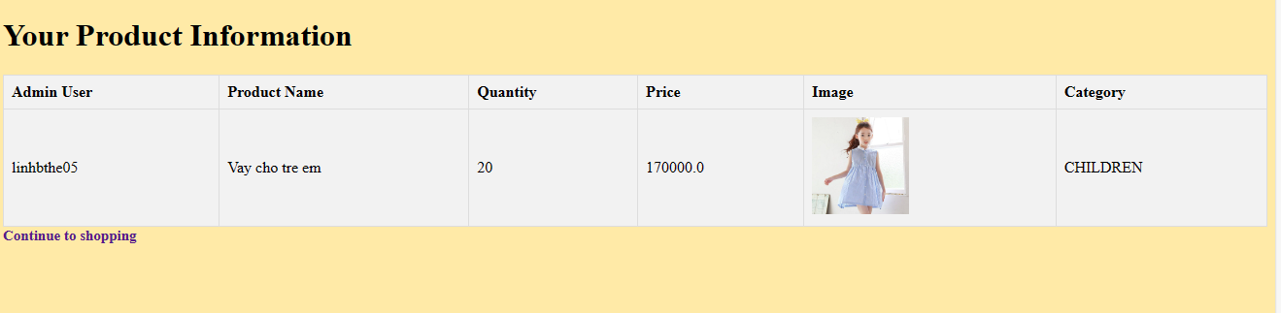

**V, Conclusion**

- Pros:

+ Create an user interface with basic functione: Search, Insert, Show, Delete, Login, Logout, Sign up, Delegate Rights.

+ Having normal interface to use and variety products.

- Cons:

+ Lack of advanced function such as: integration bank to pay, admin system, shipper system.

- Learning:

+ To create interface pagination, user’s product management.

+ About Java Web: Connect use Servlet, JSP.